**Timeline**

1. Prepare to defend critical information against a top tier Foreign Intelligence Entity (FIE), begin Open Source Research (OSR) and administrative review (~21 days prior to beginning assessment.

2. Continue OSR and complete Enterprise Protection Risk Management (EPRM) assessment (~D-21 – D-day), if using EPRM to assist in facilitating the assessment.

3. In-brief CO, present schedule of events, assign responsibilities to assessment team.

4. Conduct assessment (D-day – D+3)

a. Conduct interviews

b. Review trash (“dumpster dives”)

c. Conduct compartment/office walkthroughs

d. Observe daily procedures

5. Compile results, create/conduct out-brief for CO (D+3/D+4)

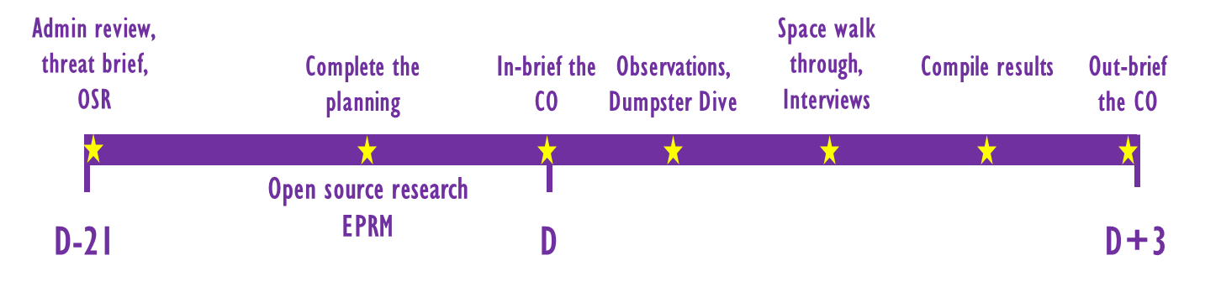

6. Depending on the level or scope of an assessment, outside organizations may be included in a command assessment. For example, a close access team (CAT), or Red Team may be requested to conduct aggressor type activities, as long as that is pre-approved by the Commander.